Instructional Days: 11-14

Topic Description: In this lesson, students learn how computers can be used as a tool for visualizing data, modeling and design, and art in the context of culturally situated design tools. Connections between the design of the tools and mathematics will be explored.

Objectives:

The student will be able to:

▪ Explain how computers can be used as tools for visualizing data, modeling and design, and art.

▪ Identify mathematical connections in the output of the tools.

▪ Edit an image using Photoshop or similar tool.

Outline of the Lesson:

• Research on the cultural background associated with the design tool (25 minutes)

• Design tool tutorials (30 minutes)

• Creation of designs using the design tools (65 minutes)

• Online presentation on how to get started using Photoshop (15 minutes)

• Design editing (30 minutes)

• Preparation of presentations (40 minutes)

• Group presentations (15 minutes)

Student Activities:

• Groups do research on the cultural background information associated with the design tools they are assigned and discuss their findings.

• Groups prepare and deliver brief presentations on the cultural aspects of their design tools.

• Students complete design tool tutorials.

• Groups create designs using the design tools.

• Watch an online presentation on how to get started using Photoshop.

• Edit images created with the design tools.

• Groups prepare presentations.

• Groups deliver presentations.

Teaching/Learning Strategies:

• Post the possible design tools:

o Virtual Bead Loom

o Pacific Northwest Basket Weaver

o Navajo Rug Weaver • 

Note: You may substitute the Graffiti Art tool if you choose.

• Display the first page of each tool in order to give students an idea of what each does. (http://www.csdt.rpi.edu )

• Students divide into groups to work on the tool of their choice. Group sizes will depend on the size of the class. You may need to have more than one group per tool.

• Each member of the group should go through the entire cultural background section individually.

o Answer any questions posed in the section in their journal. o Look for and write down the mathematical connections.

• All group members discuss the section. o Resolve answers to questions and mathematical connections.

• Each member of the group completes the tutorial. o Students should go through the tutorial at their own pace, but discuss with other members as questions arise. (Note: The bead loom tutorial is online; the other two are not. The print versions included here have been adapted from the bead loom tutorial.) o Encourage students to record in their journal points that they want to remember.

• Groups create designs using the design tool software. o Each person should choose one of the goal pictures for practice and discuss any issues with the other group members. o Groups decide whether they want to create one design as a group or have multiple designs for their presentation. o Groups work on design/designs—these should be their own creations rather than a mimic of one of the preloaded designs. • Edit designs with Photoshop (or another photo editor of choice).

o Have students watch the online tutorial and create an account.

o Edit the design. • Prepare presentations to include:

o Culture—an explanation in their own words o Math connections—an explanation in their own words o Demo of software o Display of designs—include a written description of how they created their design

• Groups deliver presentations o Groups respond to questions from other students and teacher. o Specifically ask what did the computer scientists who created the tools need to know?

(computer science, graphics, culture, anthropology, visual arts, language arts, history) • Display of designs—include a written description of how they created their design.

Resources:

• Culturally Situated Design Tools—http://www.csdt.rpi.edu (site and adaptations of tutorials courtesy Ron Eglash)

• Virtual Bead Loom Tutorial

• Pacific Northwest Basket Weaver Tutorial

• Navajo Rug Weaver Tutorial

• Culturally Situated Design Tools Project Sample Rubric

• http://www.photoshop.com

• Apps for Blind students

Virtual Bead Loom Tutorial

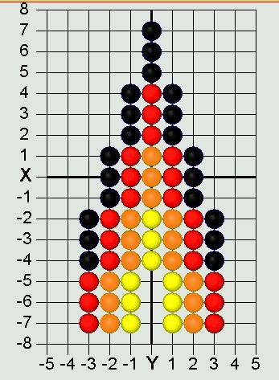

Part 1

The Virtual Bead Loom simulates the same grid pattern as the traditional bead loom. Users place colored circles in columns (the Y-axis) and rows (the X-axis).

There are several tools for placing beads on the virtual loom. In each case you use the "tab" key or the mouse to move your cursor to the field for entering the coordinates, then you enter them, and then press the button for the shape tool. The point tool places a single bead:

The line tool places lines of beads. You specify the two endpoints of the line. Diagonal lines tend to be jagged, but resizing the grid can help that (see "Options menu" on next page).

The rectangle tool fills in a rectangle of beads. You specify two vertices (lower right and upper left). The rectangles of this tool are always aligned with the axes.

 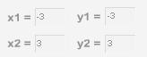



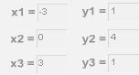

Part 2

The triangle tool fills in a triangle of beads. You specify the three vertices.

The iterative triangle tool: Our first triangle tool made jagged edges, while traditional beadwork has beautifully regular edges. We interviewed some native beadworkers, and found that their algorithms were iterative. The triangle iteration tool reflects this tradition of indigenous mathematics. For example, the triangle in the beadwork at the top of this page was made by adding one bead on each side of the row, every three rows, as you go in the -Y direction.

* • "Direction"—determines in which direction your rows will accumulate
* • Starting at X, Y—that is the center of the starting row.
* • "After every ___ rows"—lets you determine how many rows you go through before adding more beads to the end.
* • "Add ___ to both ends"—the number of beads that will be added on each side of the center each time.
* • "For ___ rows in total"—how many rows you will bead in this triangle.  Note that this tool has two colors—some traditional bead work shifts color in each iteration. This allows you to select the starting color and ending color; the software does the shifting for you.

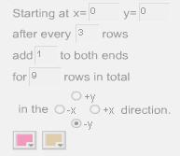

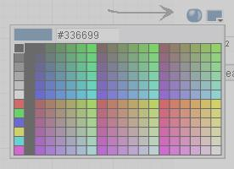

Part 3

There are also controls that apply to all the tools. "Clear" deletes everything. Normally "Create" is selected, so that your tools will fill their specified shape with beads. "Remove" will erase all beads in the specified shape, so if you make an error use "undo" not "remove." The color button allows you to select the bead color. Clicking on the little square in the upper right of the screen will give you a list of all the colors you have selected so far. The "Save" menu allows you to save the work on your hard drive and edit the design later. Make sure your file name is only letters, not spaces or numbers, and that you go back to the same computer when you want to edit your work.

The "Options" menu allows you to resize the grid smaller or larger—maximum size is 150 by 150. You can also change the location of the coordinate values, hide the grid, or create a title or notes about your design. You can also switch to Wampum beads, using either traditional 1X2 Wampum or a 1X1 Wampum (which is easier for math teaching—special thanks to Joyce Lewis of the Onondaga Nation for that concept!).

Printing: after you have your design completed, do a screen capture. In windows you can do that by pressing the "print screen" button on your keyboard, usually located at the upper right above the F10 key. On a Macintosh press shift + apple + 3 at the same time (also shift + apple +4 to select just a portion). That screen capture will save an image of the entire screen to your clipboard. You can then paste the clipboard image into a blank canvas in Word, Photoshop, Imaging (comes free in the "Accessories" folder in Windows) or other image editor.

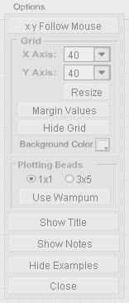

Pacific Northwest Basket Weaver Tutorial

Part 1

The Virtual Basket Weaver simulates the same grid pattern as the traditional basket weaving loom. Users place colored circles in columns (the Y-axis) and rows (the X-axis).

There are several tools for placing wefts on the virtual loom. In each case you use the "tab" key or the mouse to move your cursor to the field for entering the coordinates, then you enter them, and then press the button for the shape tool. The point tool places a single weft:

The line tool places lines of wefts. You specify the two endpoints of the line. Diagonal lines tend to be jagged, but resizing the grid can help that (see "Options menu" on next page).

The rectangle tool fills in a rectangle of wefts. You specify two vertices (lower right and upper left). The rectangles of this tool are always aligned with the axes.

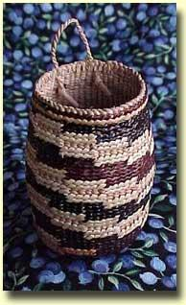





Part 2

The triangle tool fills in a triangle of wefts. You specify the three vertices.

The iterative triangle tool: Our first triangle tool made jagged edges, while traditional basket work has beautifully regular edges. The triangle iteration tool reflects the tradition of indigenous mathematics. For example, a triangle can be made by adding one weft on each side of the row, every three rows, as you go in the -Y direction.

* • "Direction"—determines in which direction your rows will accumulate
* • Starting at X, Y—that is the center of the starting row.
* • "After every ___ rows"—lets you determine how many rows you go through before adding more wefts to the end.
* • "Add ___ to both ends"—the number of wefts that will be added on each side of the center each time.
* • "For ___ rows in total"—how many rows you will weft in this triangle.  Note that this tool has two colors—some traditional basket work shifts color in each iteration. This allows you to select the starting color and ending color; the software does the shifting for you.



Part 3

There are also controls that apply to all the tools. "Clear" deletes everything. Normally "Create" is selected, so that your tools will fill their specified shape with wefts. "Remove" will erase all wefts in the specified shape, so if you make an error use "undo" not "remove." The color button allows you to select the weft color. Clicking on the little square in the upper right of the screen will give you a list of all the colors you have selected so far. The "Save" menu allows you to save the work on your hard drive and edit the design later. Make sure your file name is only letters, not spaces or numbers, and that you go back to the same computer when you want to edit your work.

The "Options" menu allows you to hide the grid, or create a title or notes about your design.

Printing: after you have your design completed, do a screen capture. In windows you can do that by pressing the "print screen" button on your keyboard, usually located at the upper right above the F10 key. On a Macintosh press shift + apple + 3 at the same time (also shift + apple +4 to select just a portion). That screen capture will save an image of the entire screen to your clipboard. You can then paste the clipboard image into a blank canvas in Word, Photoshop, Imaging (comes free in the "Accessories" folder in Windows) or other image editor.



Navajo Rug Weaver Tutorial

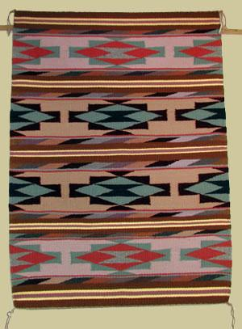

Part 1

The Virtual Rug Weaver simulates the same grid pattern as the traditional rug loom. Users place colored circles in columns (the Y- axis) and rows (the X-axis).

There are several tools for placing wefts on the virtual loom. In each case you use the "tab" key or the mouse to move your cursor to the field for entering the coordinates, then you enter them, and then press the button for the shape tool. The point tool places a single weft:

The line tool places lines of wefts. You specify the two endpoints of the line. Diagonal lines tend to be jagged, but resizing the grid can help that (see "Options menu" on next page).

The rectangle tool fills in a rectangle of wefts. You specify two vertices (lower right and upper left). The rectangles of this tool are always aligned with the axes.







Part 2

The triangle tool fills in a triangle of wefts. You specify the three vertices.

The iterative triangle tool: Our first triangle tool made jagged edges, while traditional rug work has beautifully regular edges. The triangle iteration tool reflects the tradition of indigenous mathematics. For example, a triangle can be made by adding one bead on each side of the row, every three rows, as you go in the -Y direction.

* • "Direction"—determines in which direction your rows will accumulate
* • Starting at X, Y—that is the center of the starting row.
* • "After every ___ rows"—lets you determine how many rows you go through before adding more wefts to the end.
* • "Add ___ to both ends"—the number of wefts that will be added on each side of the center each time.
* • "For ___ rows in total"—how many rows you will weft in this triangle.  Note that this tool has two colors—some traditional basket work shifts color in each iteration. This allows you to select the starting color and ending color; the software does the shifting for you.



Part 3

There are also controls that apply to all the tools. "Clear" deletes everything. Normally "Create" is selected, so that your tools will fill their specified shape with wefts. "Remove" will erase all wefts in the specified shape, so if you make an error use "undo" not "remove." The color button allows you to select the weft color. Clicking on the little square in the upper right of the screen will give you a list of all the colors you have selected so far. The "Save" menu allows you to save the work on your hard drive and edit the design later. Make sure your file name is only letters, not spaces or numbers, and that you go back to the same computer when you want to edit your work.

The "Options" menu allows you to hide the grid, or create a title or notes about your design.

Printing: after you have your design completed, do a screen capture. In windows you can do that by pressing the "print screen" button on your keyboard, usually located at the upper right above the F10 key. On a Macintosh press shift + apple + 3 at the same time (also shift + apple +4 to select just a portion). That screen capture will save an image of the entire screen to your clipboard. You can then paste the clipboard image into a blank canvas in Word, Photoshop, Imaging (comes free in the "Accessories" folder in Windows) or other image editor.



Culturally Situated Design Tools Project Sample Rubric

Group Members Names: (up to 4)

_______________________ _______________________ _______________________ _______________________

Do you have?

Points Possible

Yes No Points Earned

Product

Title with group members’ names

5

Information related to the culture (explanation in own words) 10

Mathematical connections (explanation in own words) 10

Demo of software 5

Display of designs (explanation of how the design was created) 15

Design is original 10

Design has been edited with a photo editor 10

Presentation

All group members participate

10

Present all required parts of project

15

Answer questions from audience 10

Extra Credit

Project exhibits creativity above and beyond Up to 10

TOTAL: 100 + 10